**­Level 4/5 Group 14 – week 6 –**

**Date and time of meeting/ duration**

* 07/03/2018 – 2 – 4

**Who attended?**

* Ethan Ward
* Mircea Lazar
* Petrut Vasile
* Toby White – not present, let us know via email.

**Topic**

* Talked about the email exchange between Mircea and Toby
* Talked about tasks that will be set for this weeks sprint
* Why some f the tasks were not completed

**Notes/Ideas from this meeting**

No work that I can find for two of Toby’s tasks on Jira, even though they are set to “In Progress”.

He is not in today so I will have to talk to him about it on the Friday meeting.

This week there was some disagreements within the group mainly between Mircea and Toby. I have included screen shots of the emails down below so the conversation can be seen.

The background task that Mircea was referring to in the email was one given to Toby in an earlier week on Jira and was moved to completed. When asked in the meeting for that sprint where it was (as it was not on GitHub) Toby said that it was done and that he would upload it later.

Proposed solution to the problem:

Toby and Mircea decide on a day to go through their tasks and the art work to get a better idea of their work style and make sure that there is no overlap on the art assets again.

Additionally Ethan will make sure that toby is moving items in Jira and uploading to GitHub.

^^^^^^^^^^^^^^^^^^^^^Before the meeting with Rob^^^^^^^^^^^^^^^^^^^^

After talking to Rob to find the best possible solution to the problem, we decided that the project would run smoother if Micea was not part of the group any more.

From this point onwards the group will include:

* Ethan
* Petrut
* Toby

I will still be talking to Toby on Friday to go over the Jira Issues and to go over the new tasks he will be given.

**Meetings before / on Wednesday?**

Friday 9th at 11 to talk about the design of the game (Ethan, Mircea and Toby)

Monday 12th at 12 to make sure everyone is ok with their tasks

Wednesday 14th at 11 with Rob for meeting with lecturer

|  |  |  |
| --- | --- | --- |
| Name | Tasks | Allocated time |
| Ethan | * As a programmer I need to make the code look neat * As a programmer I need to fix the pendulum bug that means two sometimes appear * As a programmer I need to get a minimum of 8 people to play test the game | * 2h * 1h * 3h |
| Petrut | * As a programmer I need to rework the pendulum to use a physics system instead of a maths system * As a programmer I need to get a minimum of 8 people to play test the game | * 1h * 1h |
| Toby | * As a designer I need to finish the health assets that are currently in a prototype stage * As a designer I need to work on the animation of player 1 for 1h 30m to get it closer to completion * As a designer I need to complete the player 2 character design * As a designer I need to work on the attack animation for 1h * As a designer I need to finalize a colour pallet | * 1h 30m * 1h 30m * 1h * 1h * 1h |

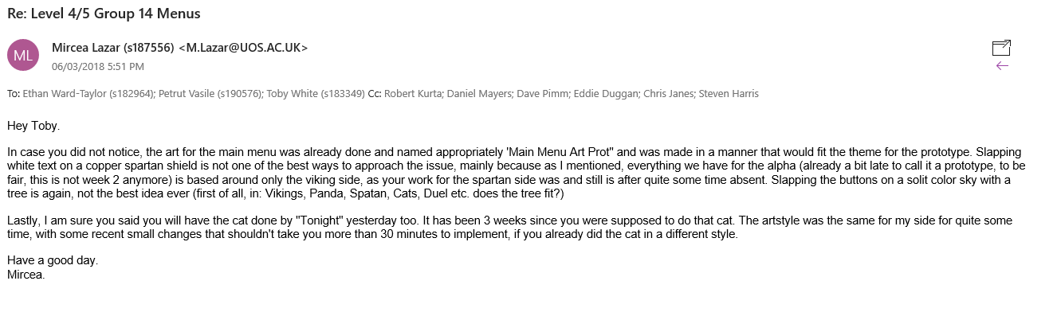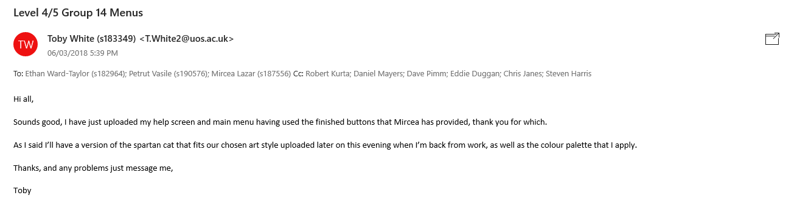Emails:

